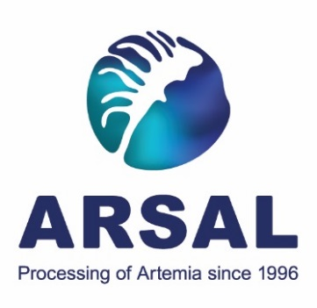

ARSAL, LLC
Instructions for dry activated Artemia cysts incubation
Please, note: before incubation we arrange a meeting via online platform with our RnD Director to assist you with the process.
The product contains activator to provide the declared hatching percentage, please shake the package well before usage.
Cysts without prior hydration and disinfection are to be placed directly into the incubation solution at the rate of 2g per 1 liter.
If the package is not fully used, after opening the package content must be mixed thoroughly (to uniform distribution of the activator).
Water preparation: prepare purified filtered sea water, we also recommend the use of products to lower the bacterial level of the solution or whatever methods of physical sterilization (UV, Ozone).

The incubation solution should have a salinity of 30 ppt, pH value of the medium is to be adjusted to pH 8.0-8.5. If pH is lower than recommended – increase it with sodium bicarbonate (NaHCO₃), adding it to the incubation solution at the rate of 2g per liter.
Incubation proceeds within 24 hours under constant aeration, at temperature of 27-29 ° C and 1500-2000 lux illumination.
Cysts have hatching rate – 80% and 85% minimum, according to the package.
If our recommended incubation conditions completely fulfilled, and the results do not match the declared hatching, please carry out additional tests increasing concentration of cysts up to 2.5 g/l, 3 g/l.
Alternative – using same cysts quantity, but less volume of water (for instance, 2 g of cysts/900ml of water).
The rest of the incubation parameters remain unchanged.

1C, Gagarina str., Yarovoye, Altai Region, Russia, 658839
TEL.: +7 905 989 23 98
Website: artemia-arsal.com
E-mail: esm@artemia-arsal.ru

